When C++ compiles a function containing a try block it creates

a) EXCEPTION_REGISTRATION structure for every function as its local variable

struct EXCEPTION_REGISTRATION
{
EXCEPTION_REGISTRATION *prev;
DWORD handler;
int id;
DWORD ebp;
};

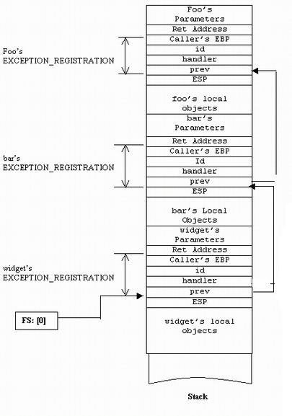

It is used to register the exception callback with the operating system that it calls when exception occurs.

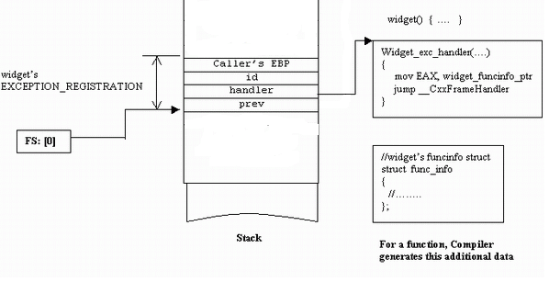
The head of the exception chain is pointed to by FS:[0] register.

b) Exception callback function.

fun_exc_handler()
{
MOV EAX,fun_funinfo_ptr;
jump __CxxFrameHandler;
}
Function's prologue creates this structure on its stack frame and registers it with the operating system.

//initialize EXCEPTION_REGISTRATION structure
EXCEPTION_REGISTRATION reg, *preg = &reg;
reg.handler = (DWORD)fun_exc_handler;

//get the current head of the exception handling chain
DWORD prev;
_asm
{
mov EAX, FS:[0]
mov prev, EAX
}
reg.prev = (EXCEPTION_REGISTRATION*) prev;

//register it!
_asm
{
mov EAX, preg
mov FS:[0], EAX
}

The epilogue restores the EXCEPTION_REGISTRATION of the caller.

c) funinfo object

struct funinfo
{
signature;
unwind_count;
punwind_table;
tryblock_count;
ptryblock_table;
};

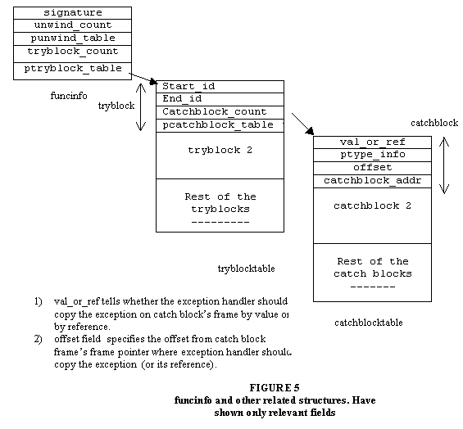

d) tryblock table

struct TryBlock
{
start_id;
End_id;
Catchblock_count;
pcatchblock_table;
*pnextTryBlock;
};

At compile time, the compiler assigns each try block a start id and end id. The compiler generates tryblock data structure for each try block with in the function.

At the time of exception, the exception handler reads this id from the frame and checks the tryblock structure to see if the id is equal to or falls in between its start id and end id. If it does, then the exception originated from with in this try block. Otherwise, it looks at the next tryblock structure in tryblocktable.

e) catchblock table I

struct catchBlock
{
val_or_ref;
ptype_info;
offset;
catchblock_addr;
*pnextCatchBlock;
};
Once exception handler finds the try block, it can traverse the catchblock table associated with the try block to see if any catch block is interested in catching the exception. Please note that in case of nested try blocks, the exception that originated from inner try block also originated from outer try block. The exception handler should first look for the catch blocks for the inner try block. If none is found, then it looks for the catch blocks of the outer try block. While laying the structures in tryblock table, C++ puts inner try block structure before the outer try block.

f) Unwindtable which is an array of unwind structures.

void foo()
{
T t1;
//.
}

When compiler encounters object definition, it generates a short routine that knows about the object's address on the frame (or its offset from the frame pointer) and destroys this object.

typedef void (*CLEANUP_FUNC)();

The compiler assigns each local object a unique id and writes its id value on the frame.

void foo()
{
T t1;
_id = t1_id; //statement added by the compiler
//.
}

Before calling the destructor for the object to write the id of the previous region. Compiler generates a data structure for the function, unwindtable, which is an array of unwind structures.

struct unwind
{
int prev;
CLEANUP_FUNC cf;
};

For every definition in the function, there is one unwind structure entry in the table.The structure entries appear in the unwindtable in the same order as their corresponding regions appear in the function.

When exception handler has to cleanup the frame, it reads the current id from the frame and uses it as an index into the unwind table. It reads the unwind structure at that index and calls the clean up function as specified by the second field of the structure. This destroys the object corressponding to this id. The handler then reads the previous unwind structure from unwind table at an index as specified by prev field. This continues until end of list is reached (prev is -1).

throw E();

C++ translates throw statement into something like:

a) compiler generates excpt_info structure for E.

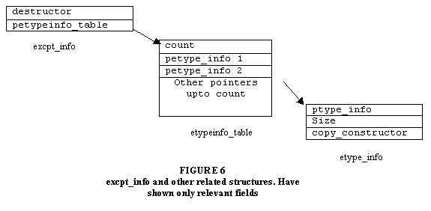
b) E e = E(); //create exception on the stack

c) calls _CxxThrowException(&e, E_EXCPT_INFO_ADDR);

d) _CxxThrowException passes control to the operating system through software interrupt

e) The operating system packages these two parameters in _EXCEPTION_RECORD structure

struct _EXCEPTION_RECORD
{
DWORD ExceptionCode;
DWORD ExceptionFlags;
_EXCEPTION_RECORD *ExcRecord;
PVOID ExceptionAddress;
DWORD NumberParameters;
DWORD ExceptionInformation[15];
} EXCEPTION_RECORD;

- If the ExceptionCode represents C++ Exception code is 0xe06d7363
- Exception handler looks at the ExceptionFlags field of the _EXCEPTION_RECORD structure to determine what action to take. If the value is EH_UNWINDING (defined in Except.inc), that is an indication to the exception handler that the stack is being unwound and it should clean its stack frame and return
- *ExcRecord pointer to _EXCEPTION_RECORD in case of nested exception
- ExceptionAddress specifies the address where Exception occured
- Number of defined elements in the ExceptionInformation array.
- ExceptionInformation array contains pointer to the exception and the excpt_info structure

f) Calls the exception handler pointed to by FS:[0]

g) Exception handler passes funcinfo structure's address to __CxxFrameHandler function

h) __CxxFrameHandler inspects to see if there is any catch block in the function interested in catching the current exception.

- If it does not find any, it returns ExceptionContinueSearch value back to the operating system. Operating system gets the next node off the exception handling list and calls its exception handler.

j) If it finds, it performs stack unwinding. It starts from the beginning of the exception handling list pointed to by FS:[0] and calls the exception handler at each node, telling it that the stack is being unwound. In response, the handler calls destructor for all the local objects on the frame and returns.

k) The exception handler needs to activate functions stack frame before calling the catch block.

l) Exception handler copies the exception object or its reference to catch block's frame.

m) After copying the exception and activating the frame, exception handler calls the catch block.

n) Catch block returns the address where control should be transferred in the function after try-catch block.

o) The exception handler removes all the frames including its own by setting the ESP at the end of the function's frame and transfers control at the end of try-catch block.

How does it know where the end of function's frame is? It has no way of knowing. That's why the compiler saves it on function's stack frame for the exception handler to find it

